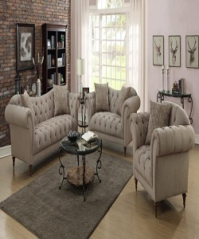

### Light Broun sofa

$209.15

Availability: In stock

Fort living sectional sofa light brown by home elegance leather Chelsea home Colby sofa set light brown. This furniture features a cyan color and seat for comfortable seating and the modern stool design will add a splash of style to your lounge area Luxury modern leather fabric corner sectional sofa with Centre table.